COURSE NAME: Theory of Computation COURSE CODE: CSA13

COURSE OUTCOME COVERED

CO2: Deign Finite Automata DFA, NFA, ε-NFA and demonstrate their equivalence for recognizing regular languages. (BL:3)

Assessment Tool Weightage: 40%

QUESTIONS: 5 Total Marks:25 Duration : 1 Hour

Design Task

Code of Conduct:

I J.Goutham Kumar Reddy(192311140) certify that this submission is my original work and that I have adhered to the guidelines specified for this assessment.
I understand that any violation of academic integrity rules will result in disciplinary action.
J.Goutham Kumar Reddy
Signature of the student:

- Design the regular expression for the language represented by the given
automata 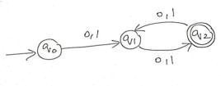
- Consider the following grammar S->aSc|T|U|e
T-> bTc|e U->aUb|
e
A} What is the language defined by the grammar?
- Give the derivation tree for the word aaabbc
- A Grammar is Ambiguous if there exists two distinct derivations for a word. Is the above grammar ambiguous? Justify.

- Design a non deterministic finite automata with ε-transitions to represent the language denoted by the regular expression 00*1+11*0
- I)Show that if L1 and L2 are regular then (L1+l2) also regular Ii)Is the language { a^p| p is prime} regular? Justify

- Design minimized automata, Consider the DFA given below. Find the states that are equivalent and construct a minimum state automata equivalent to the given automata. Draw the minimized automata, write its transition table and mark initial and final states

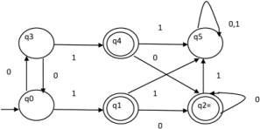

RUBRICS FOR CALCULATION
Criteria | Weightag  e | Level 4 –  Exemplar y (5  Marks) | Level 3 – Proficient  (4 Marks) | Level 2 – Developing  (2–3 Marks) | Level 1 – Beginni ng (0–1 Mark)
Conceptual Understan din g | 30 | Demonstra t es clear and complete understanding of the concept | Good understandi ng with minor gaps | Basic understandi ng with some  misconception s | Poor or incorrect understan din g
Accuracy  of  Answer | 25 | Completely correct answer with no errors | Mostly correct with minor errors | Partially correct with noticeable errors | Incorrect or irrelevant answer
Application of  Knowledge | 20 | Correctly applies concepts to solve the question/probl e  m | Applies concepts with minor mistakes | Limited or partially correct application | No or incorrect application
Completene ss of  Response | 15 | Covers all required parts of the question | Covers most parts with minor omissions | Covers only some parts | Incomplete or missing response
Clarity & Presentatio n | 10 | Clear, concise, and well organized answer | Understand abl e with minor issues | Somewhat  unclear or poorly structured | Difficult to  understand

Answer
1. Design the regular expression for the language represented by the given The first question asks:
Design the regular expression for the language represented by the given automata.
From the automaton in the document, the accepting states are q1, q2, and q4.
Regular Expression
The language accepted by the automaton can be expressed as: or, in∗ standard∗ regular expression notation:
1(0) +01(0)
10* + 010*
Explanation
- 10*
  - Starts with 1.
  - May be followed by zero or more 0s.
  - Examples: 1, 10, 100, 1000, ...
- 010*
  - Starts with 01.
  - May be followed by zero or more 0s. o Examples: 01, 010, 0100, 01000, ...
2. Consider the following grammar S->aSc|T|U|e

T-> bTc|e
U->aUb|e
A} What is the language defined by the grammar?
- Give the derivation tree for the word aaabbc
- A Grammar is Ambiguous if there exists two distinct derivations for a word. Is the above grammar ambiguous? Justify.
A) What is the language defined by the grammar?
The productions generate the following languages:
- T→bTc∣ε generates
- { bncn∣n≥0 }{bncn∣n≥0}
- U→aUb∣εU→aUb∣ε generates
- { anbn∣n≥0 }{anbn∣n≥0}
- (S ->aSc) adds one 'a' at the beginning and one 'c' at the end of any string generated by S. Hence, the language generated by the grammar is
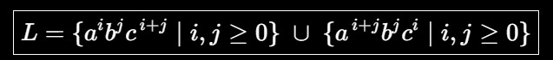where (i) and (j) are non-negative integers.
  - Give the derivation tree for the word aaabbc Leftmost derivation
S aSc aUc aaUbc aaaUbbc aaaεbbc
⇒ aaabbc
⇒

⇒
⇒
⇒
⇒
Derivation Tree

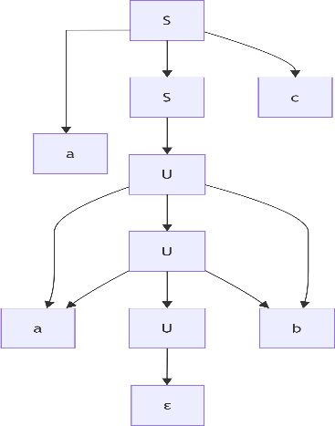

The leaves (read left to right) are:
a a a b b c which forms the string aaabbc.
  - Is the grammar ambiguous? Justify.
Yes. The grammar is ambiguous.
A grammar is ambiguous if at least one string has more than one distinct derivation (or parse tree).
For the string ε, there are multiple derivations:
  - S ⇒ ε
  - S ⇒ T ⇒ ε
  - S ⇒ U ⇒ ε
Since the same string ε has more than one valid derivation, the grammar is ambiguous.

- Design a non deterministic finite automata with ε-transitions to represent the language denoted by the regular expression 00*1+11*0
Regular Expression:
00∗1+11∗000∗1+11∗0
This represents the union of:
  - 00∗100∗1 (one or more 0's followed by one 1)
  - 11∗011∗0 (one or more 1's followed by one 0) CO2_AT2_Deisgn Task_ToC ε-NFA

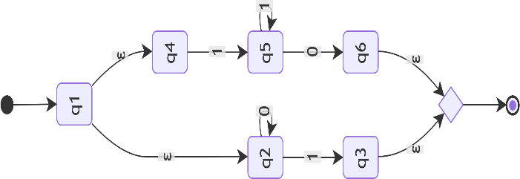

qf (Final)
Transition Table
State | Input 0 | Input 1 | ε
q0 | – | – | q1, q4
q1 | q2 | – | –
q2 | q2 | q3 | –
q3 | – | – | qf
q4 | – | q5 | –
q5 | q6 | q5 | –
q6 | – | – | qf

qf | – | – | –
Initial State: q0
Final State: qf
- I)Show that if L1 and L2 are regular then (L1+l2) also regular ii) Is the language { a^p| p is prime} regular? Justify Proof
Since L1L1 and L2L2 are regular languages, there exist DFAs:
  - M1=(Q1,Σ,δ1,q1,F1)M1=(Q1,Σ,δ1,q1,F1)
  - M2=(Q2,Σ,δ2,q2,F2)M2=(Q2,Σ,δ2,q2,F2)
Construct a new automaton by introducing a new start state with ε-transitions to the start states of M1M1 and
M2M2.
The new automaton accepts all strings accepted by either M1M1 or M2M2.
Therefore,
L(M)=L1∪L2=L1+L2L(M)=L1∪L2=L1+L2
Hence,
The union of two regular languages is also regular.The union of two regular languages is also regular.
4(ii). Is the language {ap∣p is prime}{ap∣p is prime} regular? Justify.
The language
L={ap∣p is prime}L={ap∣p is prime}
is not regular.
Justification (Using Pumping Lemma) Assume that LL is regular.
Let the pumping length be mm.
Choose the string w=apw=ap where pp is a prime number and p≥mp≥m. According to the Pumping Lemma, w=xyzw=xyz such that
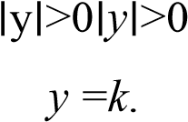
● ∣xy∣≤m∣xy∣≤m
●
Let ∣y∣=k∣ ∣
Pump yy p+1p+1 times.
The new string length becomes p+(p×k)=p(1+k)p+(p×k)=p(1+k)
Since 1+k>11+k>1, the length is composite, not prime.
Hence the pumped string is not in LL, contradicting the Pumping Lemma.
Therefore,
{app is prime} is not a regular language.{app is prime} is not a regular language.
5. Design minimized automata, Consider the DFA given below. Find the states that are equivalent and construct a minimum state automata equivalent to the given automata. Draw the minimized automata, write its transition table and mark initial and final state
Step 1: Identify Initial and Final States
- Initial State: (q_0)
- Final States: (q_1,; q_2,; q_4)
Step 2: Partition the States
Initial Partition
- Finalstates:
F={q_1,q_2,q_4}
- Non-finalstates: N={q_0,q_3,q_5}

State | Input 0 | Input 1
q1 | q2 | q5
q2 | q2 | q5
q4 | q2 | q5
Step 3: Find Equivalent States
Compare Final States

All three have identical transitions.
Therefore,
Q1 ≡ q2 ≡ q3
Compare Non-final States
State | Input 0 | Input 1
q0 | q3 | q1
q3 | q0 | q4
q5 | q5 | q5
Since (q_1,q_2,q_4) are equivalent,
- (q_0) and (q_3) always move to the same equivalence classes, so
Q0≡q3
- (q_5) is a trap (dead) state and is not equivalent to them.
Equivalent State Groups
{{q_0,q_3},{q_1,q_2,q_4},{q_5}}

Step 4: Minimized DFA
Let
- A = {q0, q3} (Start)
- B = {q1, q2, q4} (Final)
- C = {q5}
Minimized DFA

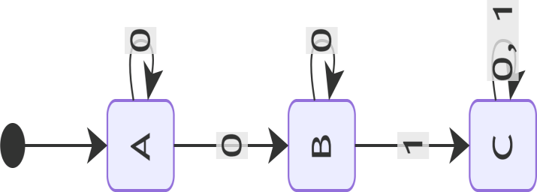

●
- A = Initial state
- B = Final state
- C = Dead (trap) state
Step 5: Transition Table
State | 0 | 1
→ A = {q0,q3} | A | B
* B = {q1,q2,q4} | B | C
C = {q5} | C | C

